Diffusive Decline of Hydraulically Fractured Deposits
Recently, oil and natural gas extraction has shifted from conventional techniques to unconventional approaches as depletion of natural reserves sets in [1][2][3][4]. The replacement approaches rely on novel mechanisms to enhance the recovery of what is often referred to as tight oil within less-porous and permeable deposits of shale and limestone.
The most common technique involves the hydraulically-induced fracturing of shale deposits. The fracturing of shale into crevices and fissures allows the trapped oil and natural gas to escape along random seams to collection points along the horizontally aligned drilling path. Figure 1 illustrates the behavior that the trapped oil will show when released from the trapped state. As the fracturing reveals a random pattern of paths, the flow of oil will also reveal a random diffusional flow away from the regions of originally high concentration as it follows the random paths.
Figure 1 : Diffusional Flow from fractured porous media
Captured
diffusional flow

x
The cross-sectional capture of oil is represented mathematically as the integrated flow of oil away from a dispersed volume of point sources. The uncertainty both in (1) the volumetric extent and (2) the variable diffusivity within a multiphase porous media, makes the analysis amenable to similar MaxEnt formulations used to describe diffusion-assisted oxide growth described earlier in this paper.
Figure 2 below shows the application of the dispersive diffusive flow derived elsewhere to the cumulative production of a typical Bakken well [5]. The two parameters of the model, a median diffusion time and a scaling cumulative were adjusted to give the smallest residual error to the data.
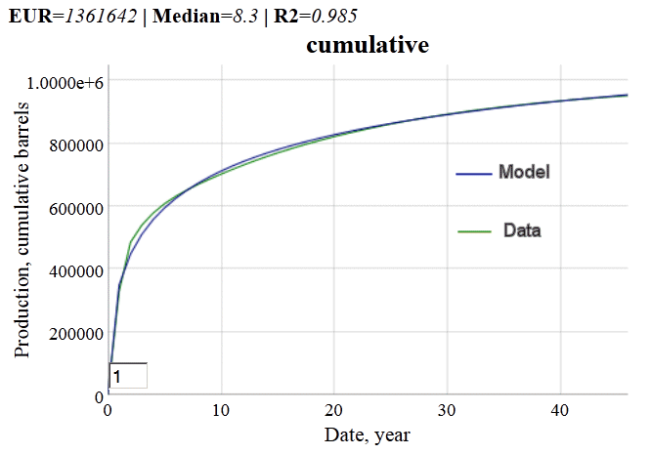
Figure 2: Cumulative production from what is referred to as a typical hydraulically fractured well in the Bakken shale formation of North Dakota. The cumulative production was monitored as a function of time from the start of extraction.
Not every well will show this good an agreement with the model (see the Annex for an independent and unbiased substantiation of the model fit), since what are referred to as “above ground” decisions can modulate the flow of oil, but in terms of a statistical average, this formulation can prove useful to estimate the expected ultimate recovery (EUR) of the typical well, after a few initial data points become available.
$$P\left(t\right)=n_{0}-n\left(t\right)=\frac{n_{0}}{1+\sqrt{\frac{τ}{t}}}$$
The model shown as Eq. 12 can be linearized to the following form, where P(t) indicates cumulative production and n₀ is the ultimate production:
$$\frac{1}{P\left(t\right)}=\frac{1}{n_{0}}+\frac{1}{n_{0}}∙\sqrt{\frac{τ}{t}}$$
When plotted and a least-squares regression is applied, the value of the intercept generates the reciprocal of the EUR, as shown below:

Figure 3: Linearization of diffusive model generates an estimate of ultimate recovery.
Another “typical” well from the North Dakota Industrial Commission report [6] does not show as good agrement with the classical dispersed diffusion model (see Figure 4), but when Eq. 12 is modified by the reversion-to-the-mean characteristic of an Ornstein-Uhlenbeck process, the fit markedly improves while the expected cumulative is cut nearly in half in this particular case.

Figure 4: The Ornstein-Uhlenbeck process suppresses the diffusional flow by limiting the extent at which the mobile solute can travel, thus generating a constrained asymptote below that of drag-free diffusion.
The drag-factor-limited diffusion in the O-U process essentially prevents the oil from traveling too far from its starting point, thus limiting the collection of oil at the well bore. The classical diffusion model thus provides an optimistic projection of ultimate recovery, while the O-U model generates a pessimistic prediction. Unfortunately, the inflection point is only visible after a sufficient duration has elapsed, meaning that the linearization technique is not as effective.
Besides oil, this model has applicability to hydrolically fractured natural gas production, as that it likely follows a similar diffusion process as for oxide and corrosion growth. This is a single impulse response profile. A typical decline curve from a set of shale gas wells is shown in Figure 5 (see page 59 of [7]).
Data source
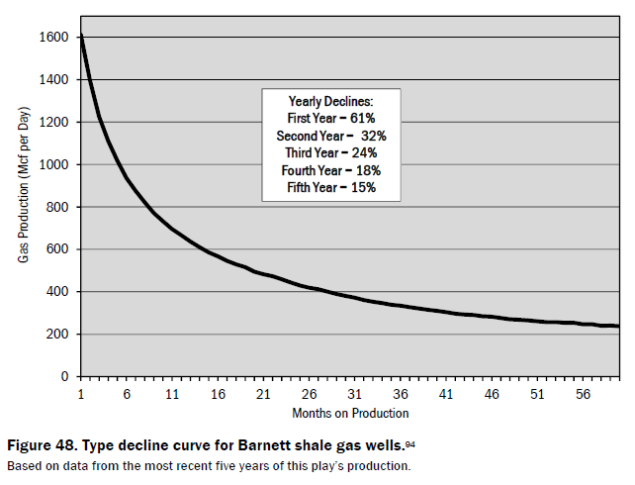
Figure 5: Typical decline curve for Barnett shale gas wells, based on the last five years of data from[7]. From the fit to the curve, production may have started on average 3 months prior to the first month plotted.
The data source description states that the numbers were taken from the most recent 5 years of production. Since we do not know the start date, we add a term t₀ to indicate this uncertainty. The instantaneous production is the derivative of the cumulative:
$$p(t)=\frac{n_{0}}{2\sqrt{t-t_{0}}}∙\frac{\sqrt{τ}}{{\left(\sqrt{t-t_{0}}+\sqrt{τ}\right)}^{2}}$$
As a best fit, the median is 203 months or 16.9 years and t₀ is 3 months, with n₀ = 3.7 trillion ft³.
The general trend described by the diffusive model is also supported by recent studies of shale gas located in the Barnett formation, where they report that “decline rate is the function of permeability, porosity and well depth and is proportional to $1/\sqrt{time}$” [8]. This agrees with the above formula for small times.
Petroleum engineers and geologists who specialize in fossil fuel reservoir modeling likely have similar analyses and heuristics (such as hyperbolic decline models) at their disposal, yet the dispersive diffusive model provides a useful explanation to the layman interested in future oil and natural gas supplies of a finitely constrained resource [1]. For example, the number of fractured wells showing a diffusive fall-off needed to keep up with demand leads to a Red Queen race of extraction activity [9][10][11].

References

[1] P. R. Pukite, The Oil Conundrum: Vol. 1 Decline, Vol. 2 Renewal, vol. 1,2, 2 vols. Daina, 2011.
[2] D. L. Goodstein, Out of gas: the end of the age of oil. WW Norton & Company, 2005.
[3] J. A. Tainter and T. W. Patzek, “Our Energy and Complexity Dilemma: Prospects for the Future,” in Drilling Down, Springer, 2012, pp. 185–214.
[4] D. Rutledge, “Estimating long-term world coal production with logit and probit transforms,” International Journal of Coal Geology, vol. 85, no. 1, pp. 23–33, 2011.
[5] S. Nordeng, “North Dakota Department of Mineral Resources Three Forks 2012 Presentation,” 15-Oct-2012. [Online]. Available: https://www.dmr.nd.gov/oilgas/presentations/EmmonsCoFB101512.pdf. [Accessed: 12-Mar-2013].
[6] D. Hvinden, “North Dakota Department of Mineral Resources Three Forks 2011 Presentation.” [Online]. Available: https://www.dmr.nd.gov/oilgas/presentations/WBPC2011Activity.pdf. [Accessed: 12-Mar-2013].
[7] J. Hughes, “Drill,Bay,Drill : Can Unconventional Fuels Usher in a New Era of Energy Abundance?” [Online]. Available: http://www.postcarbon.org/reports/DBD-report-FINAL.pdf. [Accessed: 25-Feb-2013].
[8] S. Tinker, “Frequently Asked Questions (FAQ) – BEG Barnett Shale Assessment Study | JSG News,” Jackson School of Geosciences, February 28, 20013. [Online]. Available: http://www.jsg.utexas.edu/news/2013/02/frequently-asked-questions-faq-beg-barnett-shale-assessment-study/. [Accessed: 05-Mar-2013].
[9] R. Likvern, “The Oil Drum | Is Shale Oil Production from Bakken Headed for a Run with ‘The Red Queen’?”[Online]. Available: http://www.theoildrum.com/node/9506. [Accessed: 12-Mar-2013].
[10] Raymond Pierrehumbert, “U.S. shale oil: Are we headed to a new era of oil abundance? - Slate Magazine.” [Online]. Available: http://www.slate.com/articles/health_and_science/science/2013/02/u_s_shale_oil_are_we_headed_to_a_new_era_of_oil_abundance.html. [Accessed: 17-Feb-2013].
[11] D. Coyne, “peak oil climate and sustainability: Quick update to tight oil models.” [Online]. Available: http://oilpeakclimate.blogspot.com/2012/12/quick-update-to-tight-oil-models.html. [Accessed: 12-Mar-2013].
[12] M. Schmidt and H. Lipson, “Distilling free-form natural laws from experimental data,” science, vol. 324, no. 5923, pp. 81–85, 2009.

Annex
As a method to check the quality of fit for the diffusional formulation, we used an automated tool called Eureqa [12] to see if we could find better algebraic representations without biasing the solution space with contextual information. Given an x-y paired data set, Eureqa robotically searches the space of expressions, returning a penalty for either extra complexity (size) or excessive error (fit). The best solution is found on the Pareto-efficient frontier of these two factors. Shows the results, which by finding essentially the same hidden mathematical relationships in the raw data, substantiates the choice of the dispersive diffusion formulation. This is not proof of its validity, but it adds weight to our findings.

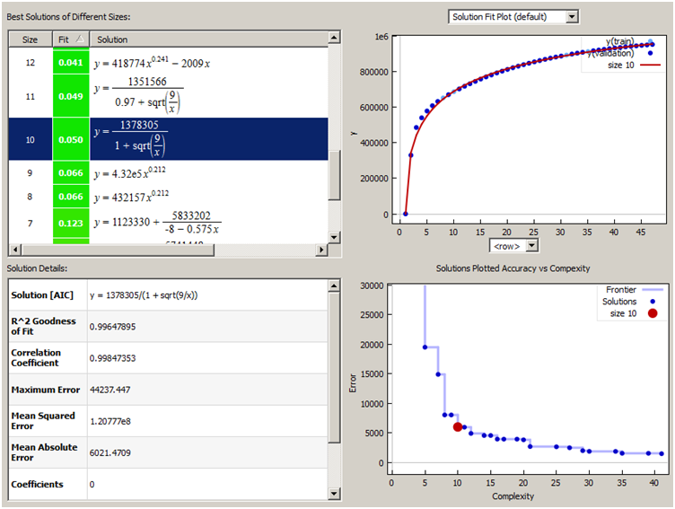
Best fit near the Pareto Frontier of reduced error and complexity

Value
Pareto
Frontier
Figure 6: Using the Eureqa search tool, a factored solution very close to the dispersive diffusional formulation (highlighted as dark blue) was returned as the best fit along the complexity/error frontier

